**CST-361 - Design Report Template**

|  |  |  |
| --- | --- | --- |
| **Topic:** | *CLC – Project Milestone 4* | |
| **Date:** | *10/18/2020* | |
| **Revision:** | *4.0* | |
| **Team:** | 1. *David Cho* | |
| 1. *Cameron Deao* | |
| 1. *Jessica Padilla* | |
| 1. *Emily Quevedo* | |
| **Weekly Team Status Summary:** | |  |  |  |  | | --- | --- | --- | --- | | **User Story** | **Team**  **Member** | **Hours**  **Worked** | **Hours Remaining** | | *IoT Integration with REST API, Weather Data DAO* | *Cameron Deao* | *8* | *0* | | *User Login and Registration DAO* | *David Cho* | *8* | *0* | | *Views Refactoring and Enhancements* | *Emily Quevedo* | *8* | *0* | |  |  |  |  | |  |  |  |  | |  |  |  |  | |  |  |  |  | |  |  |  |  | |  |  |  |  | |  |  |  |  | |  |  |  |  | |  |  |  |  | |  |  |  |  | | |
| **GIT URL:** | *https://github.com/cmdeao/CLC-361-CST-IoT/tree/CLC-Milestone-4-Submission* | |
| **Peer Review:** | *Y/N* | We acknowledge that our team has reviewed this report and we agree to the approach we are all taking. |

**Planning Documentation**

**Agile Scrum Product Backlog:**

*https://github.com/cmdeao/CST-361-CLC/blob/master/Planning%20and%20Design/CST-361-RS-SprintProductLog%20-%20CLC.xlsx*

**Agile Scrum Sprint Backlog:**

*https://github.com/cmdeao/CST-361-CLC/blob/master/Planning%20and%20Design/CST-361-RS-SprintBackLog%20-%20CLC.xls*

**Agile Scrum Burn Down Chart:**

*https://github.com/cmdeao/CST-361-CLC/blob/master/Planning%20and%20Design/CST-361-RS-SprintBurnDown%20-%20CLC.xlsx*

**Agile Retrospective Results:**

*The following table should be completed after each Retrospective on Things That Went Well (Keep Doing). An alternative to the following table is to use a Mind Mapping tool such as Coggle. If you use a Mind Mapping tool you must include a URL or Image File.*

|  |
| --- |
| **What Went Well** |
| **Weather data and User data DAO’s were established in an efficient manner.** |
| **REST API was introduced in a timely manner.** |
|  |

*The following table should be completed after each Retrospective on Things That Didn’t Go Well (Stop Doing) and What Would Be Done Differently Next Time with an Action Plan to Improve (Try Doing and Continuous Improvement). An alternative to the following table is to use a Mind Mapping tool such as Coggle. If you use a Mind Mapping tool, you must include a URL or Image File.*

|  |  |  |
| --- | --- | --- |
| **What Did Not Go Well** | **Action Plan** | **Due Date** |
| **Final iteration of weather data generation needs additional improvement.** | **Establish a stronger method of generating new days of data, while removing previous days of data.** | **10/25/20** |
|  |  |  |
|  |  |  |

**Design Documentation**

**Install Instructions:**

*Download and unzip project folder.*

*To view in Eclipse: File -> Import -> Existing Projects into Workspace -> Select root directory -> Finish*

**General Technical Approach:**

*As a team we’ll be creating an IoT weather tracking application. The project will be built within Eclipse and will leverage MVC, Façade, DAO, DTO, Interceptor, Dependency Injection, Factory design, and Singleton design.*

**Key Technical Design Decisions:**

*The project will be built utilizing a Java Dynamic Web Project framework within Eclipse. Alongside the leveraged frameworks and design patterns the team will utilize GitHub and Sourcetree for version control. Team members will create separate branches for work and merge them into ‘master’ through Pull Requests to ensure a working copy of the project at all times.*

**Known Issues:**

*No known issues currently exist.*

**Risks:**

*Establishing and connecting Eclipse to Sourcetree. Database implementation.*

**ER Diagram:**

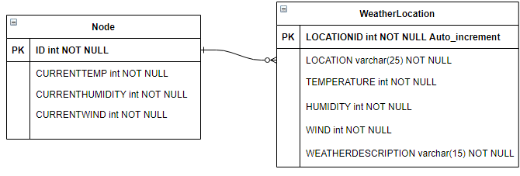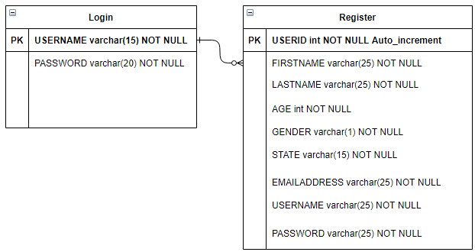

**DDL Scripts:**

*CREATE TABLE [dbo].[users]*

*(*

*USERID int IDENTITY(1,1) NOT NULL PRIMARY KEY,*

*FIRSTNAME varchar(25) NOT NULL,*

*LASTNAME varchar(25) NOT NULL,*

*AGE int NOT NULL,*

*STATE varchar(25) NOT NULL,*

*EMAILADDRESS varchar(25) NOT NULL,*

*USERNAME varchar(25) NOT NULL,*

*PASSWORD varchar(25) NOT NULL*

*)*

**Flow Charts:**

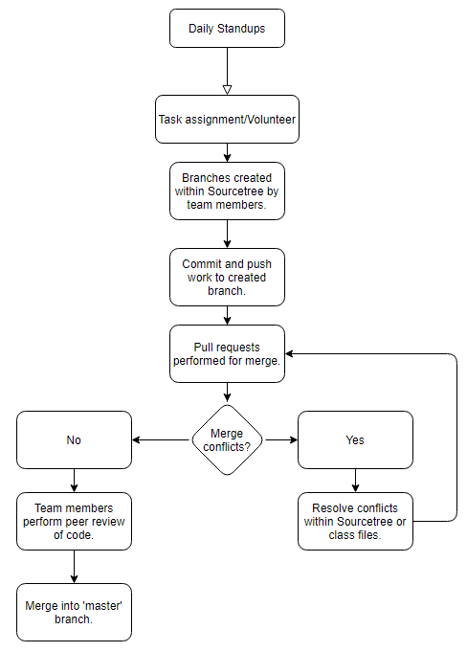

**Sitemap Diagram:**

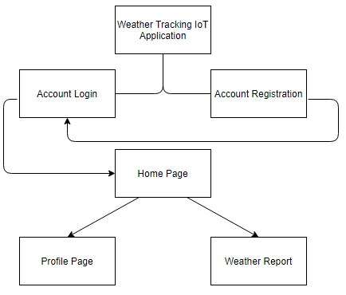

**User Interface Diagrams:**

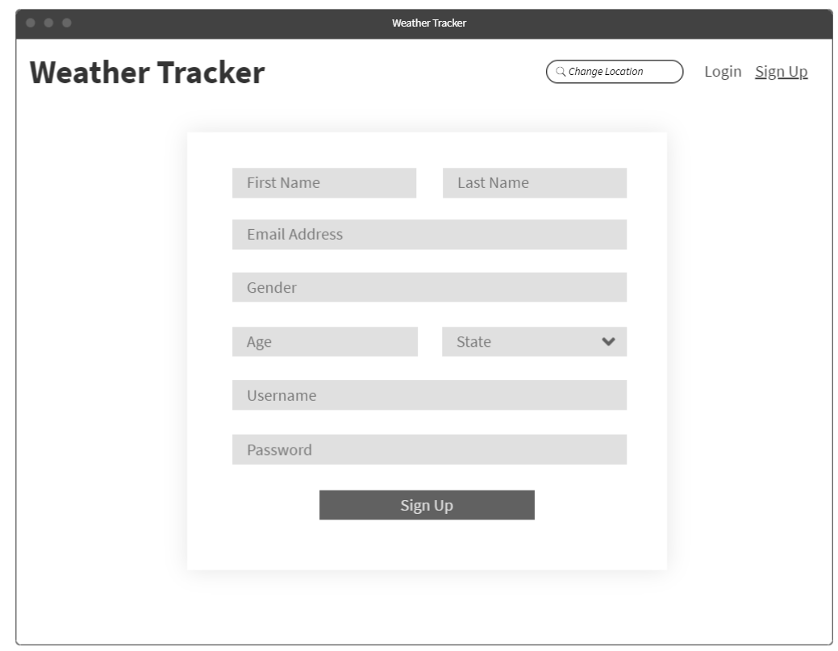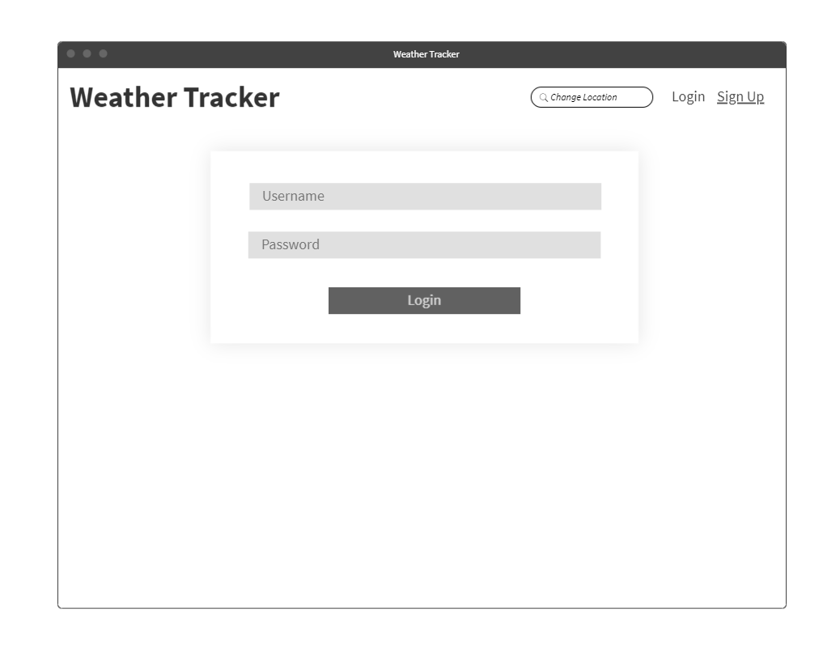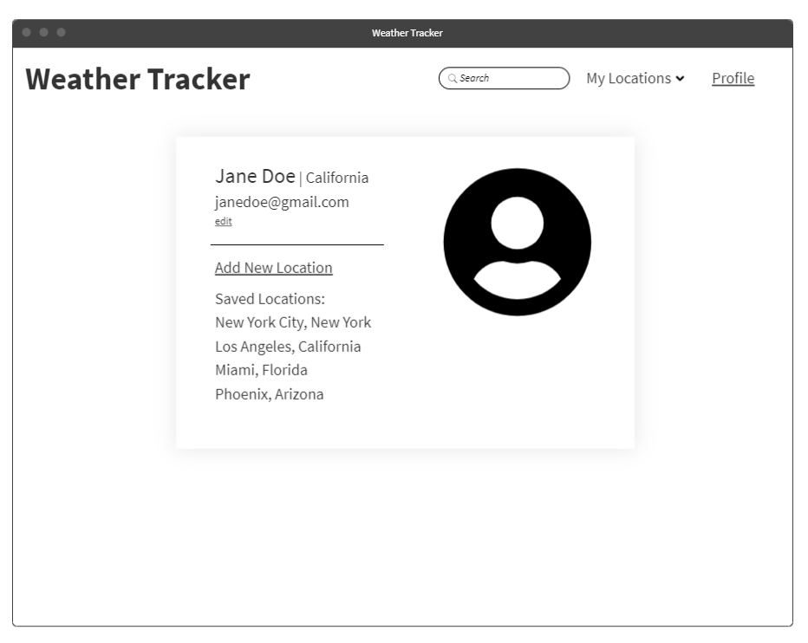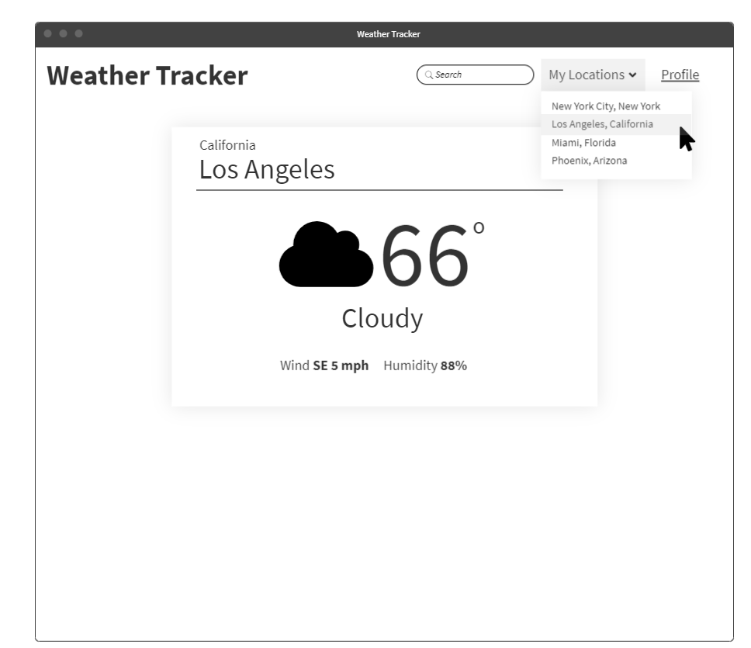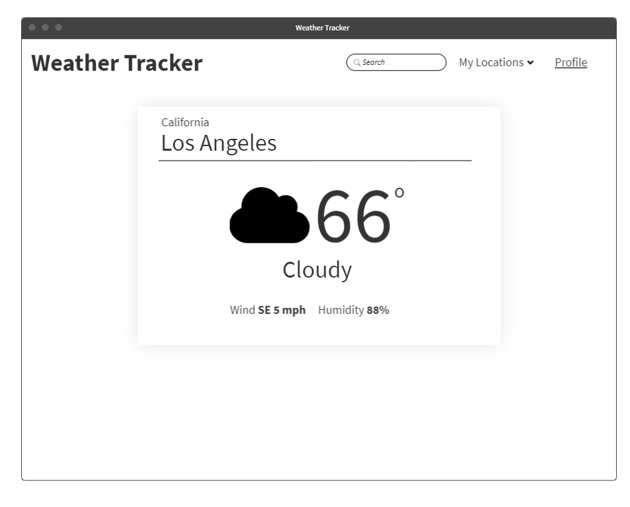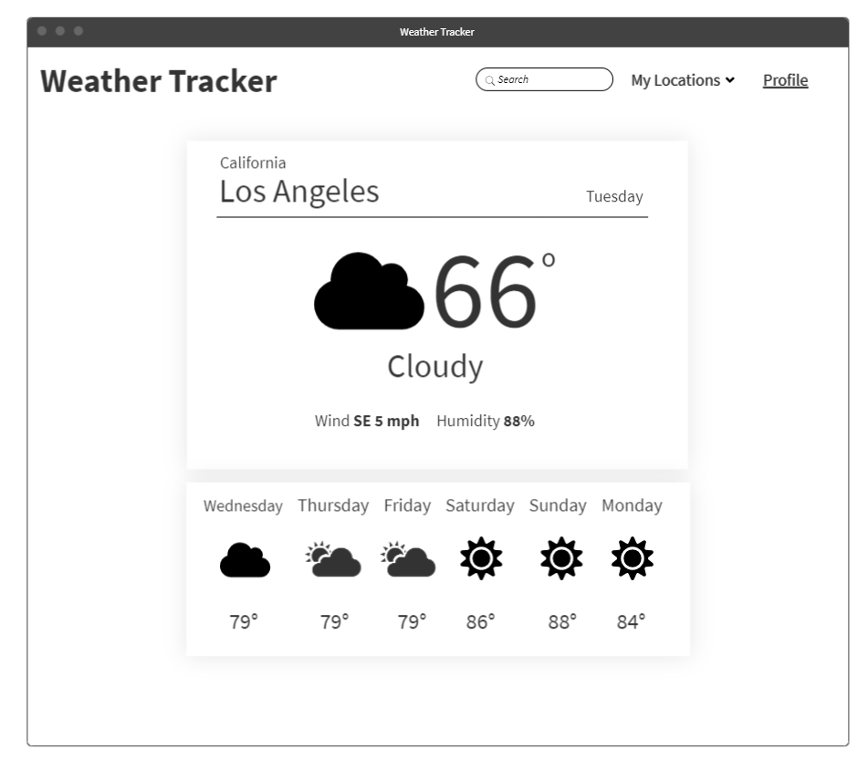

**Class Diagrams:**

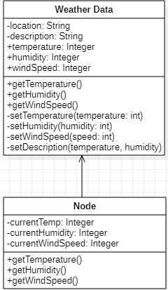

**Case Diagram:**

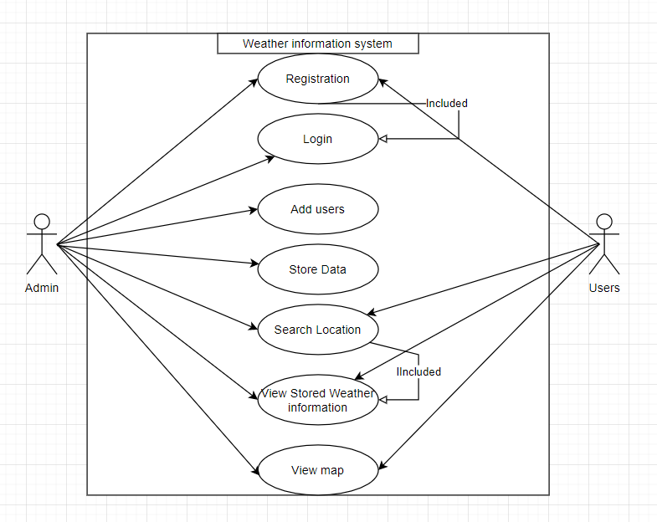

**Component Diagram:**

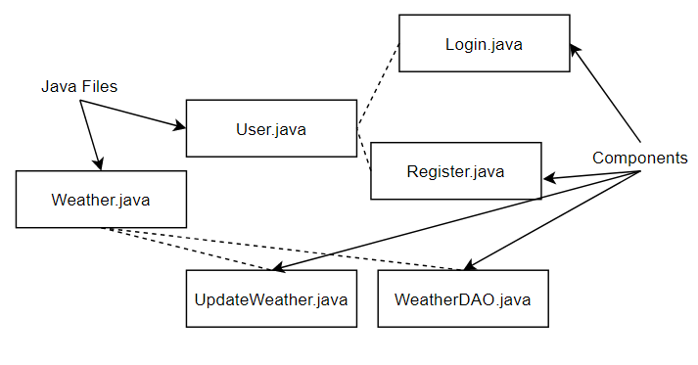

**Deployment Diagram:**

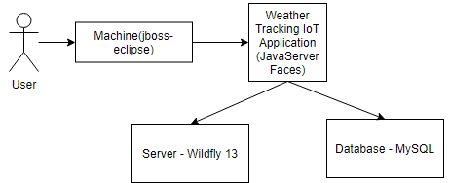

**Service API Design:**

*Currently no Third Party Service Interface APIs are planned to be consumed. As planning and development progresses various options may be leveraged.*

**Security Design:**

*Authentication and authorization will be broken down and achieved through a service class. Users will be required to register an account before accessing the application and proceed through a login service. User’s information will be stored within the database and the provided passwords will be encrypted for security measures.*

**Pseudo Code:**

*Currently no pseudo code exists the application. Pseudo code will be utilized in future milestones during the planning process of classes and services.*

**Other Documentation:**

*N/A – Currently no drawings, storyboards, or project schedules exist outside of the product log, back log, and burn down chart. This section will be updated as necessary as we move further into production and development.*